

 Hash Your First Block – Blockchain Basics and Setup.

**Objective/Aim:**  
  
 To understand the basic of blockchain and setting up the egeth and mine demo block or blockchain.

**Apparatus/Software Used:**

* Laptop
* Egeth
* Internet for research

**Theory/Concept:**

**What is blockchain?**

Blockchain is a shared, immutable digital ledger, enabling the recording of transactions and the tracking of assets within a business network and providing a single source of truth.

Within a blockchain network the data is stored in the in the all the different node or computers which make it difficult to taper the data store in it, ones the data store in blockchain I cannot be erased, to make any change in the blockchain one should have the 51% majority permission.

**The evolution of blockchain:**

Blockchain technology began with the introduction of Bitcoin in 2008, created by an anonymous figure or group known as Satoshi Nakamoto.

**Key features of blockchain technology**

* Distributed ledger technology
* Immutable records
* Smart contracts
* Public key cryptography



**Procedure:**

|  |  |  |  |
| --- | --- | --- | --- |
|  |  |  |  |
|  |  |  |  |
|  |  |  |  |
|  |  |  |  |
|  |  |  |  |
|  |  |  |  |
|  |  |  |  |

Step 1 : to hash a single block https://andersbrownworth.com/blockchain/block

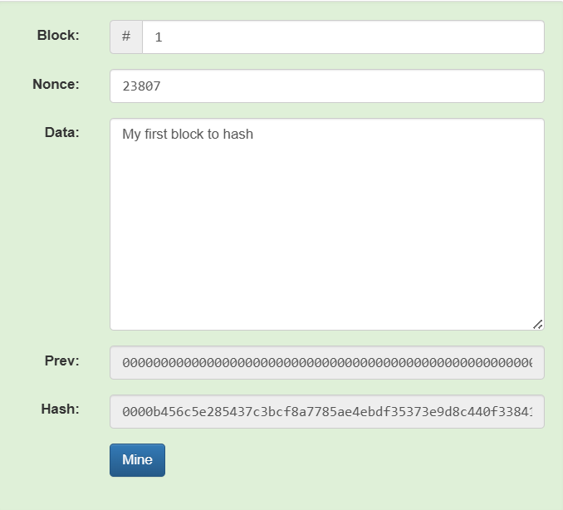Step 2 : Enter the data and you will notice that with the data the hash also changes and then mine it .

**Invalid due to data changes Valid after mining the data**

**Observation Table:**



|  |  |
| --- | --- |
| Previous hash | After adding data |
| 5ac4f1bc689f8b79e109db1d011a79c7180152d744cc8fc5125f8bbe50d97851 | 0000b456c5e285437c3bcf8a7785ae4ebdf35373e9d8c440f338410d2b76140f |



